Git-GitHub Daily Task-02
1. Install git.

- Yum install git installs git.
- Git will be automatically installed along with gitbash.
- git –version displays the git version

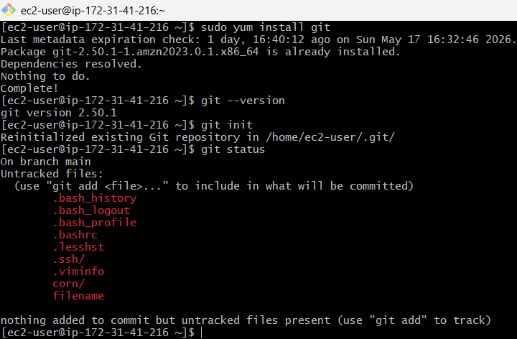

2. Create a repo in github with README.md and .ignore file.

- Launch any browser.
- Go to github.com
- Sign-in using username and password.
- Click on new button to create new repository.
- Give repository name as git-GitHub daily task-02.
- Navigate to configuration section.
- Toggle on add README.
- Click on create repository.
- Notice that README.md file is created in repository.
- Now, click on add file and create new file.
- Name the file as. gitignore.
- And commit changes.
- Observe that the file is created in repository.

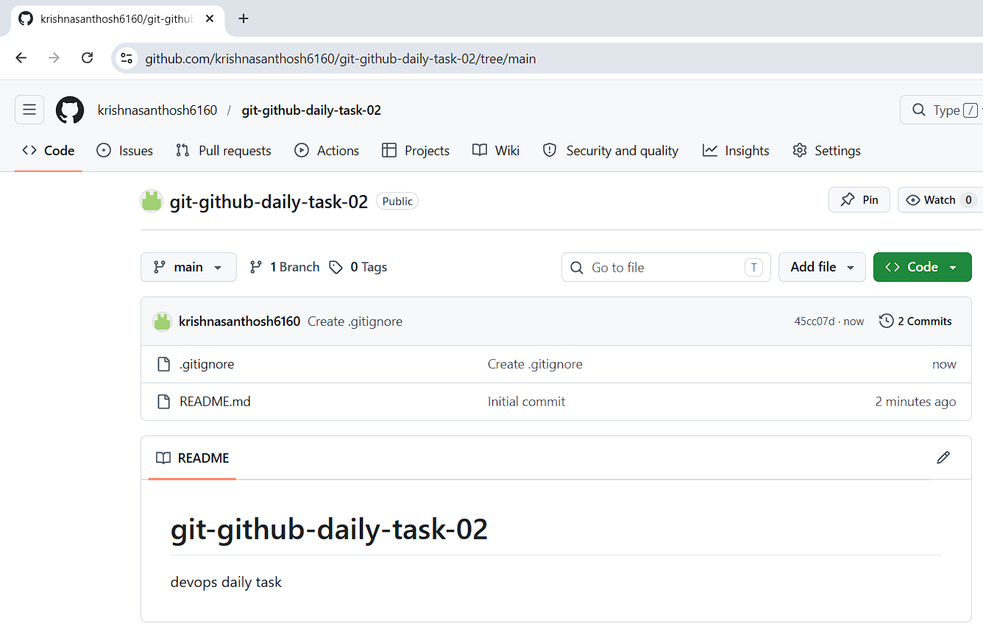

3. Clone the created repo to local.

- Open gitbash in local machine.
- Clone git clone https://github.com/krishnasanthosh6160/git-github-daily-task-02.git
- Notice that git-github-daily-task-02 directory is created.

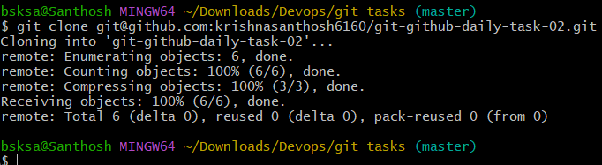

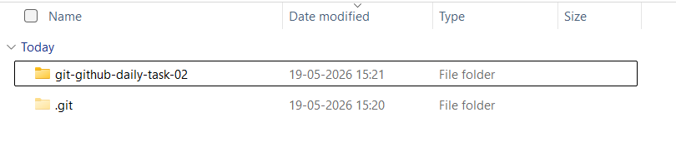

4. Create two files in local repo.

- Change to git-github-daily-task-02 directory.
- Create 2 new files swamp1 and swamp2.
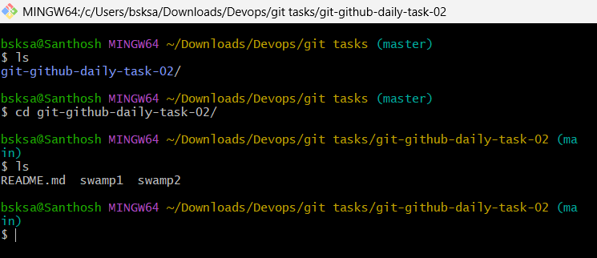

5. Commit two files and push to central Repository.

- After creating 2 new files.
- Check the status of git git status

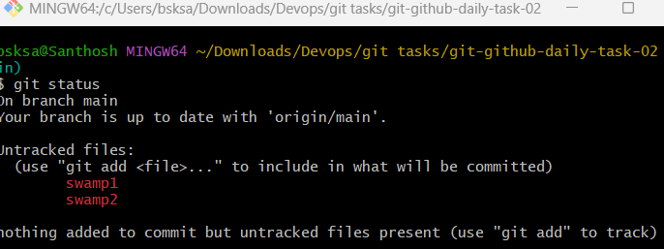

- Add the files to track git add .
- Now commit with commit message git commit -m “commit created 2 new files”

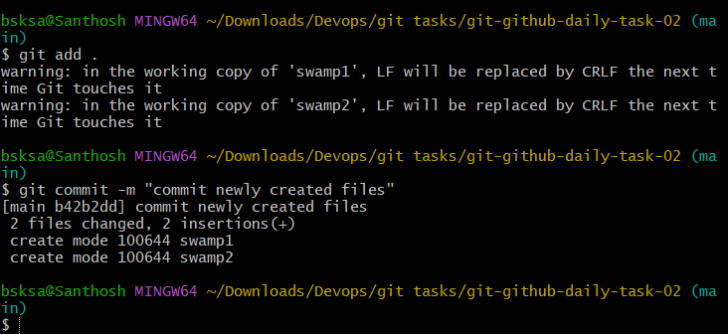

- Push to central repository. git push -u origin main

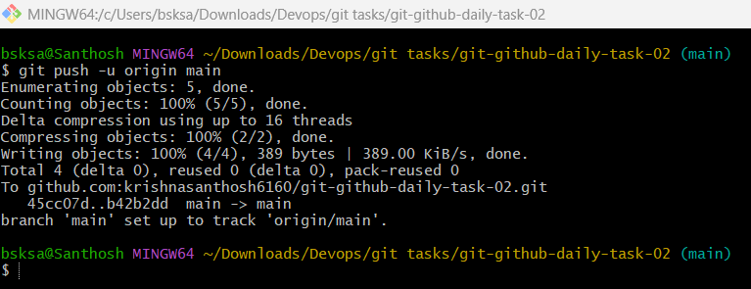

- Navigate to github repository location in browser.
- Notice that the files are pushed successfully.

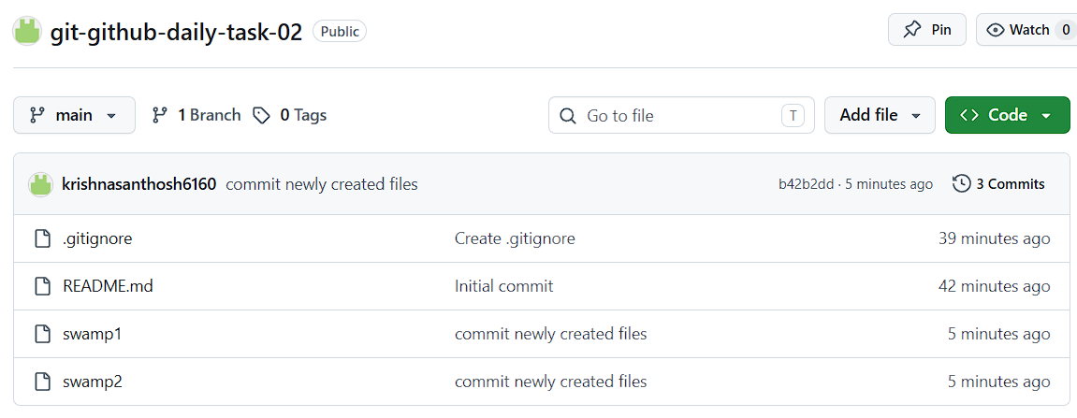

6. Create a branch in local and create a sample file and push to central.

- Create a branch in local git branch hotfix
- Check the list of branches in repository git branch –list
- Change to hotfix branch git checkout hotfix

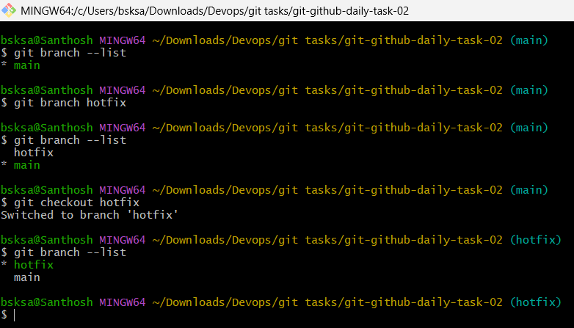
- Create a sample file.
- Git add . to track the files.
- Commit the files git commit -m “message”
- Push the file to central repository git push -u origin hotfix

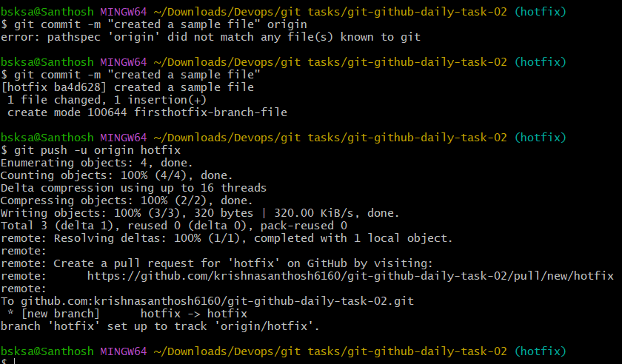

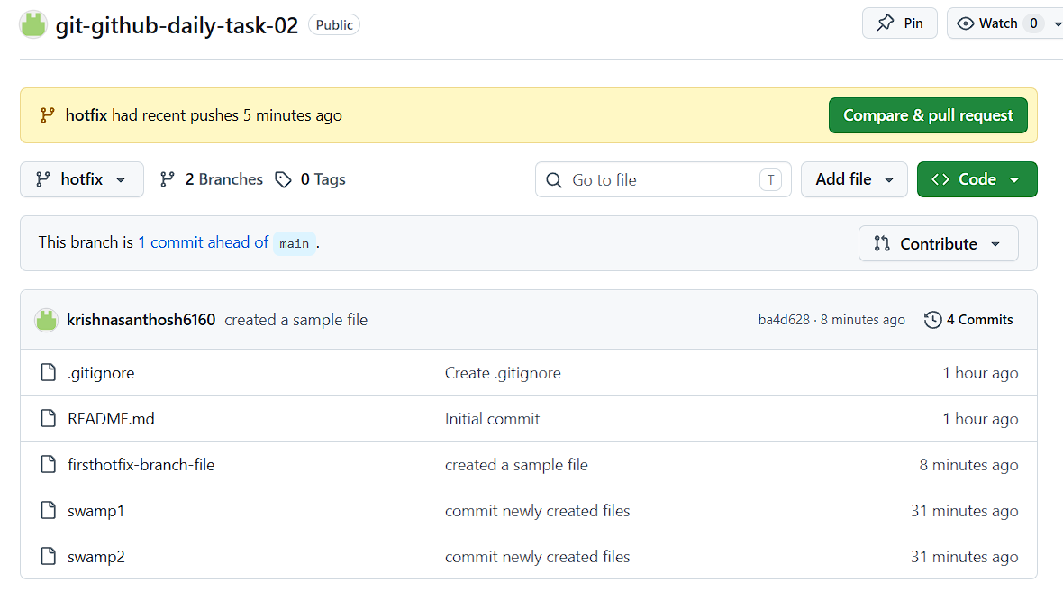

7. Create a branch in github and clone that to local.

- Go to github website via browser and sign-in.
- Create dev branch.
- Create a sample file in dev branch.

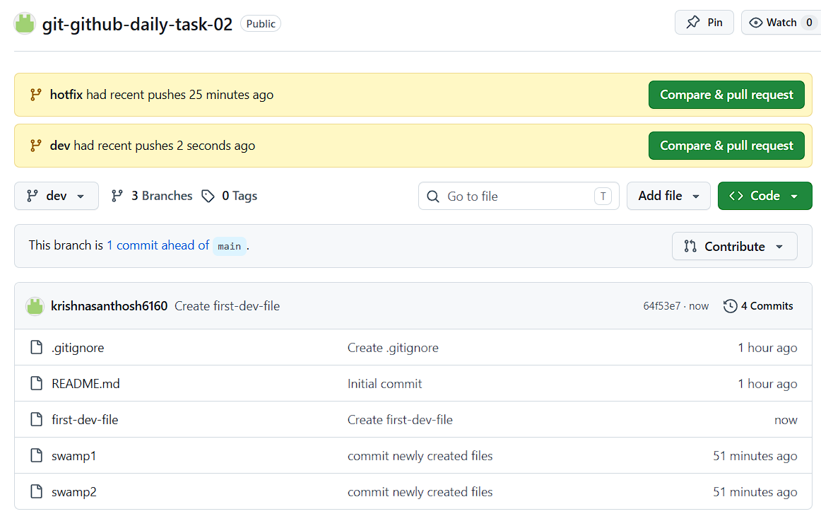

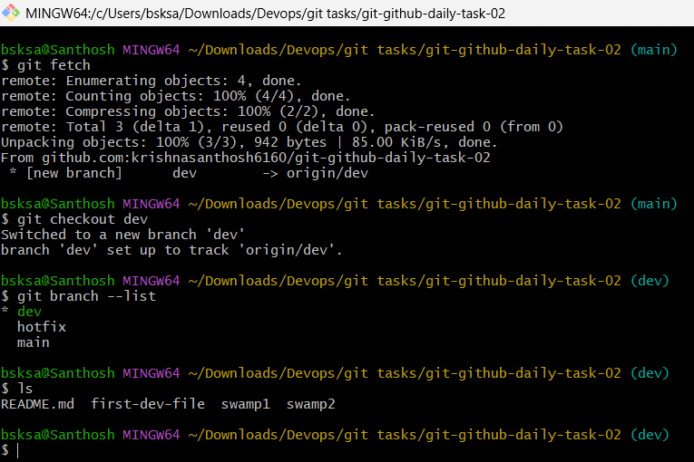

- Go to gitbash
- Fetch the configuration from the repository. git fetch
- New branch is displayed git branch –list
- Switch to dev branch git checkout dev

8. Merge the created branch with master in git local.

- git checkout main
- git pull origin main
- git merge branch name git merge dev

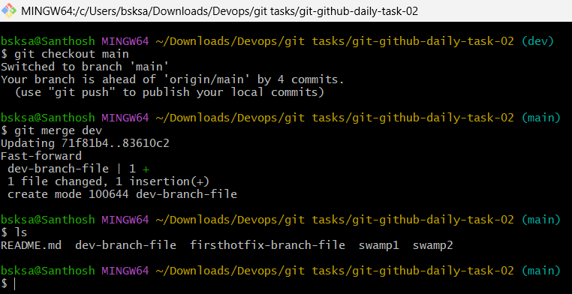

9. Merge the created branch with master in github by sending a pull request.

- Go to pull request tab.
- Click on new pull request.
- Select base and compare branch. base: main, compare: dev
- Now click on create pull request.
- Add text in title
- Click on pull request.
- Now it will check for any conflicts.
- Click on merge pull request.
- Notice that pull request successfully merged and closed

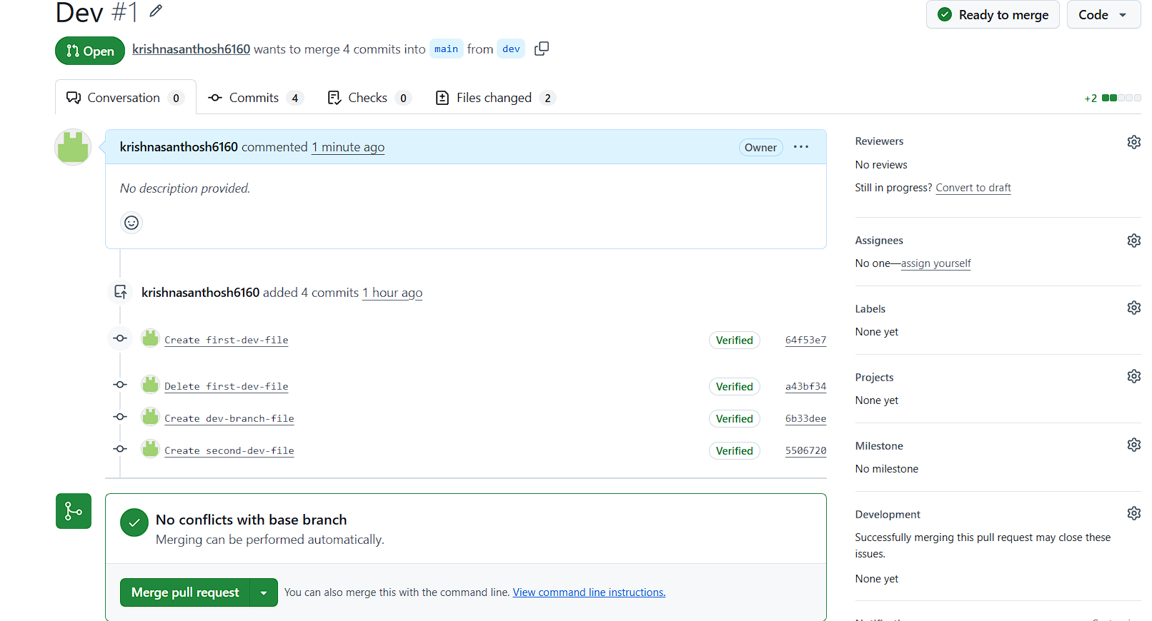

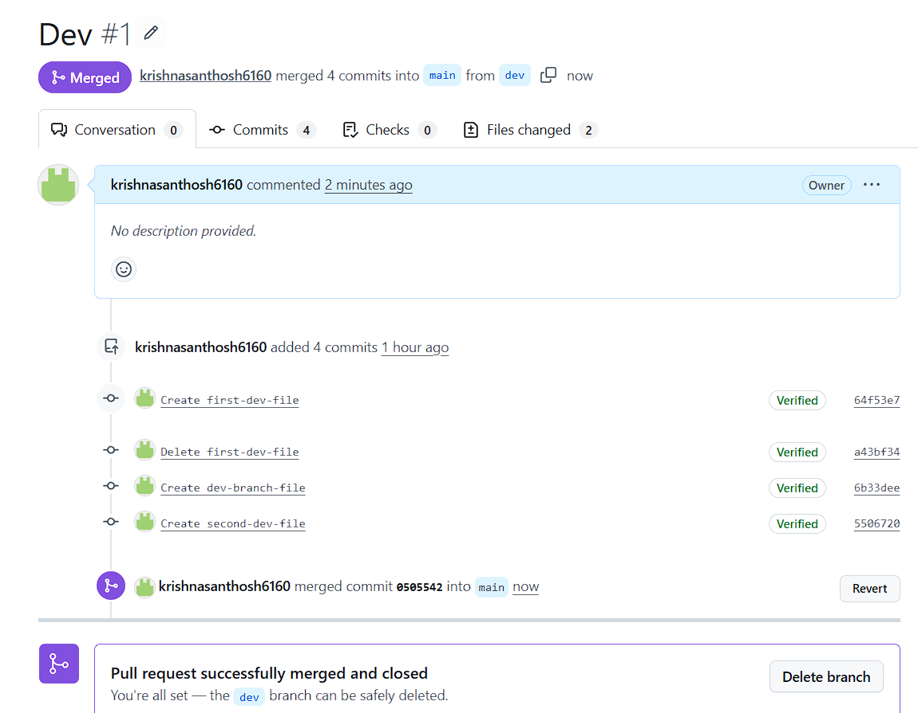

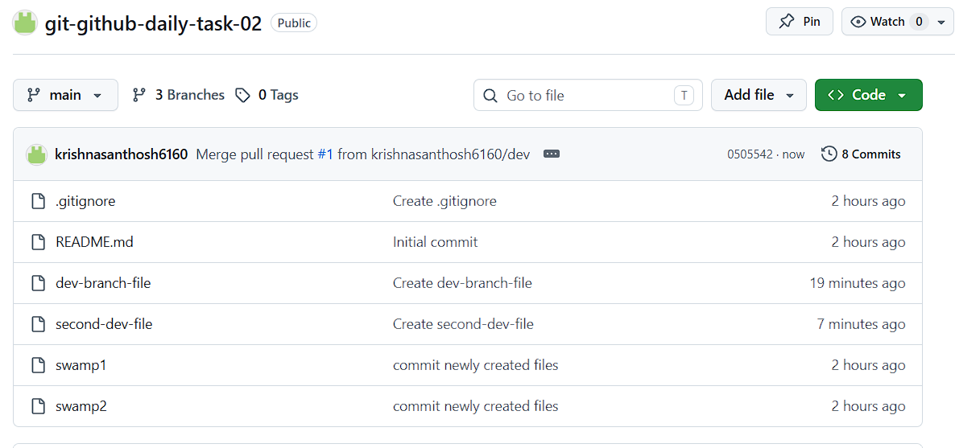

10. Create a file in local and send that to branch in github.

- Add a sample file in any branch.
- Add to tracking git add .
- Commit it git commit -m “message”
- git push -u origin “branch name”
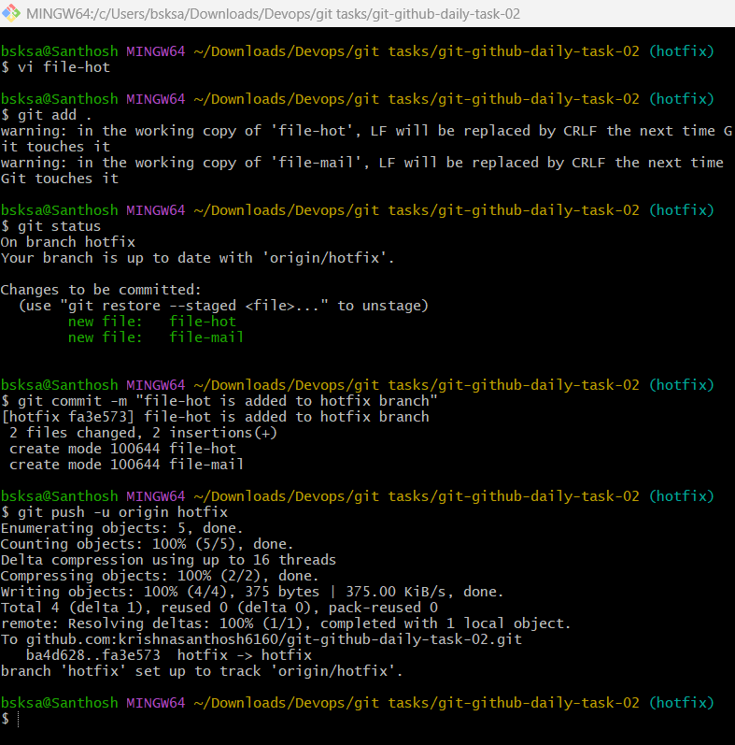

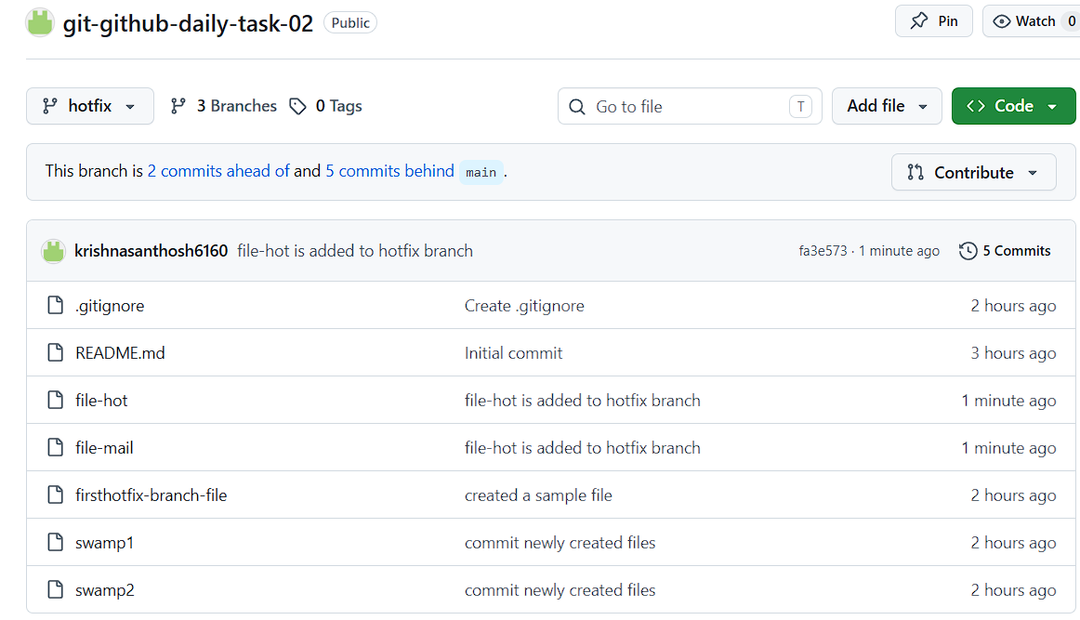

11. Clone only a branch from github to local.

- Create a directory to clone the single branch repository.
- git clone -b dev –single-branch git@github.com:krishnasanthosh6160/git-github-daily-task-02.git single-branch.

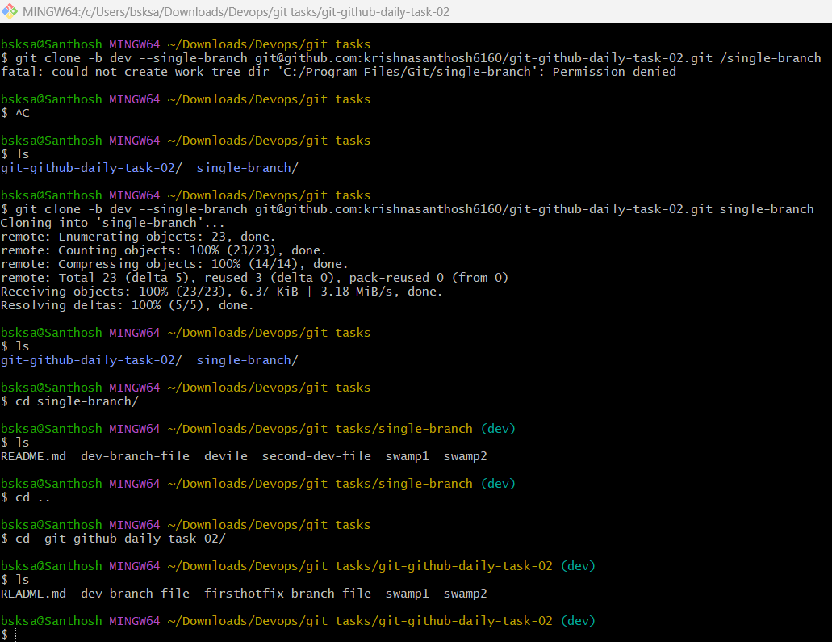

12. Create a file with all passwords and make that untrackable with git.

- Create a file with username and password in it.
- Mention the file name in “.gitignore”
- git add . and commit the changes.
- Git push -u origin main.
- Navigate to github website and click on .gitignore file.
- Notice that the password.txt is displayed.

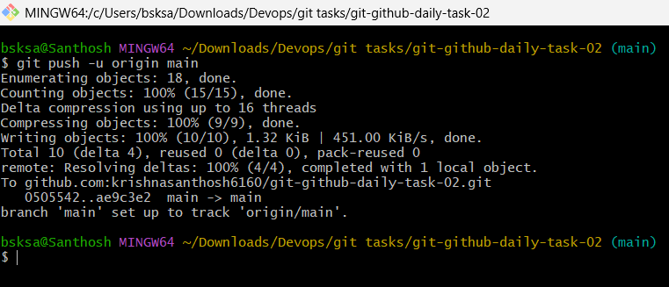

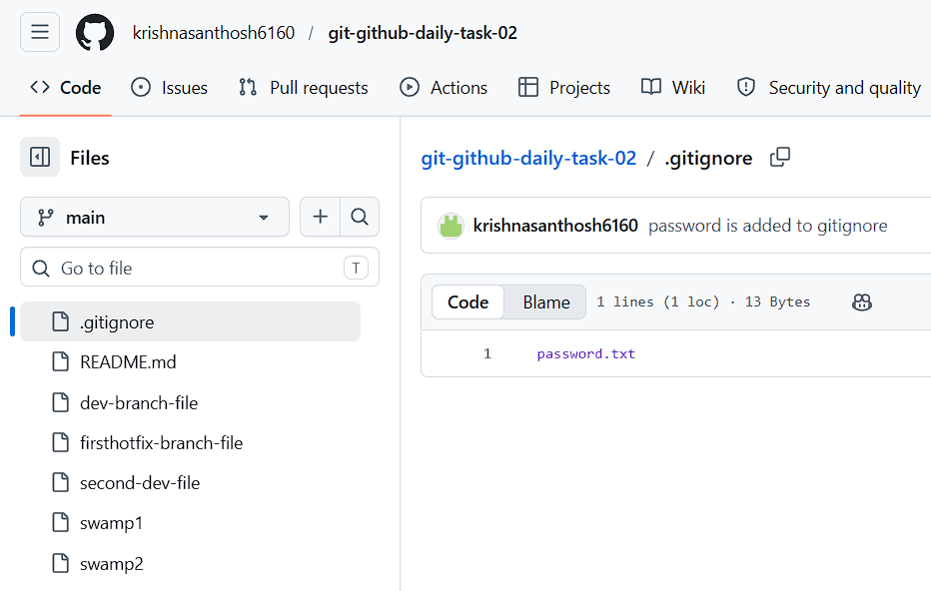

13. Make a commit and make that commit reset without savings changes.

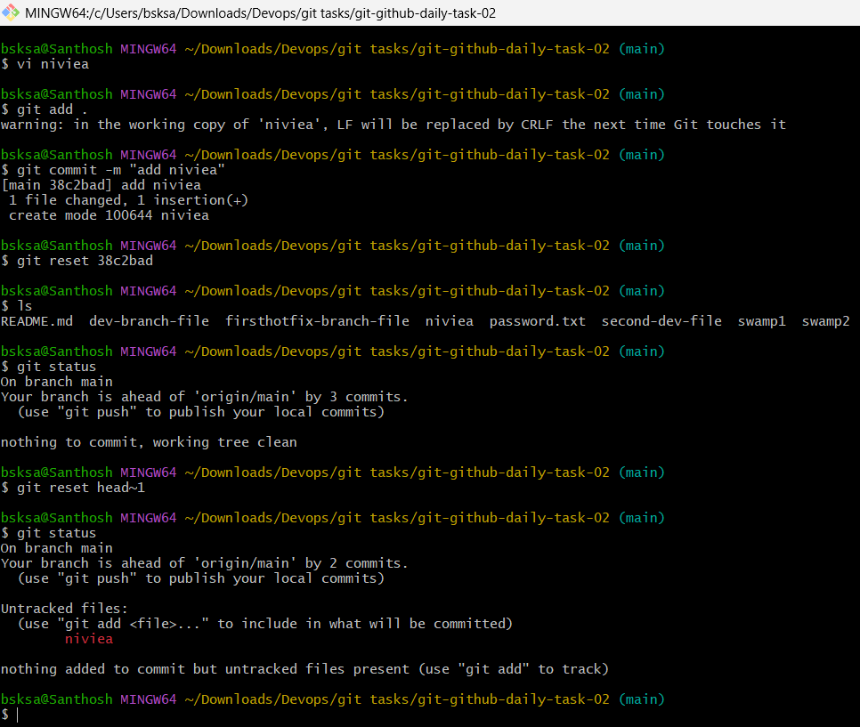

- Create a file and add to tracking using git add .
- Commit the changes.
- Untrack the file using git reset head~1

14. Revert a committed commit to the older version.

- Create a file and add to tracking using git add .
- Commit the changes.
- git revert <commit number>
- Notice that the file is deleted from the directory.

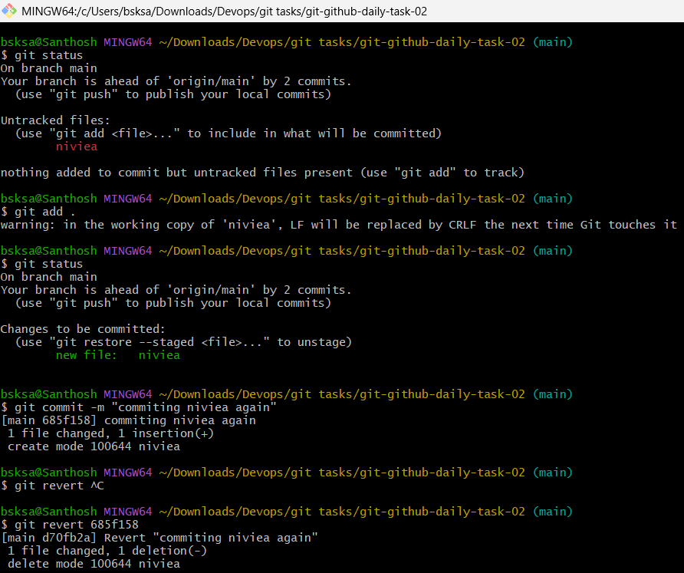

15. Push a file to stash without savings the changes and work on another file.

- Create a file and add to tracking using git add .
- Git stash

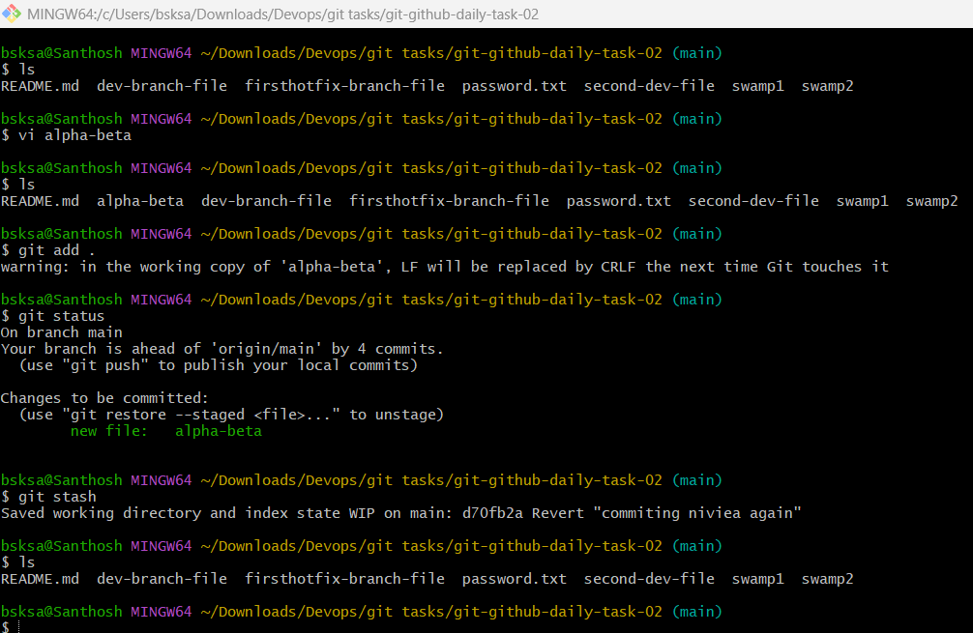

16. Undo the stash file and start working on that again.

- List out the stash list git stash list
- Get back the file to tracking area to commit git stash pop

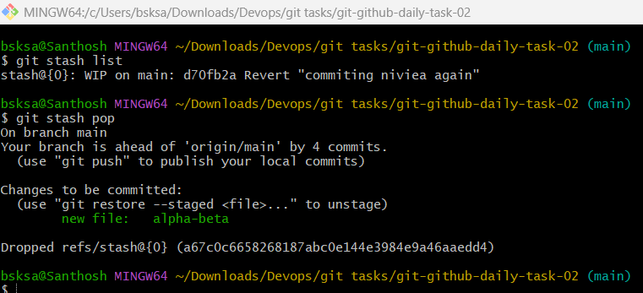

17. Generate a ssh-keygen and configure into github.

- Generate rsa key using ssh-keygen command in local machine
- Copy the path where the rsa.pub key is generated
- On terminal mention “cat pathname/rsa.pub”
- Copy the ssh key and navigate to github settings menu
- Enter SSH and GPG keys section
- Click on New SSH key
- Name the title and paste the copied rsa.pub key
- Click on add SSH key.

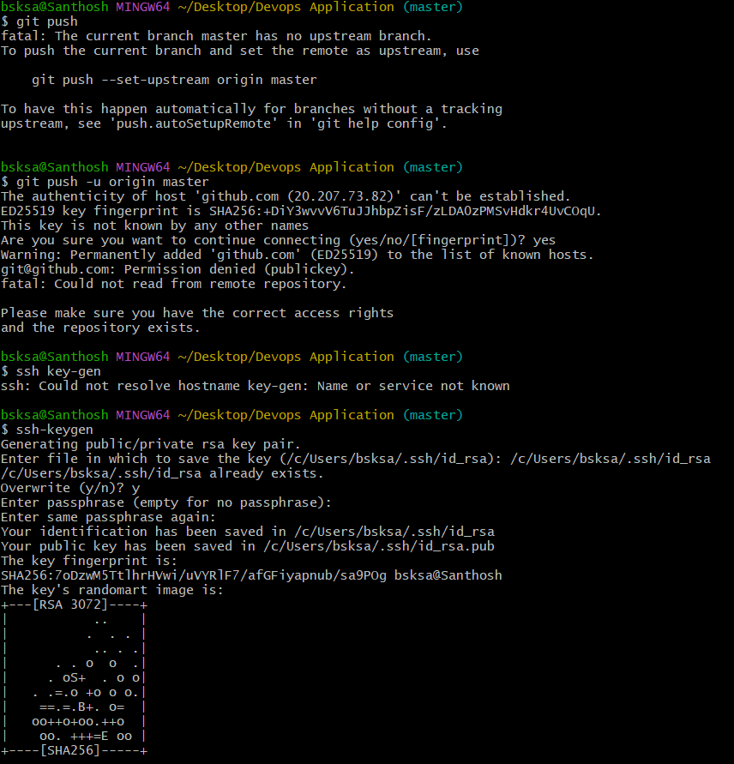

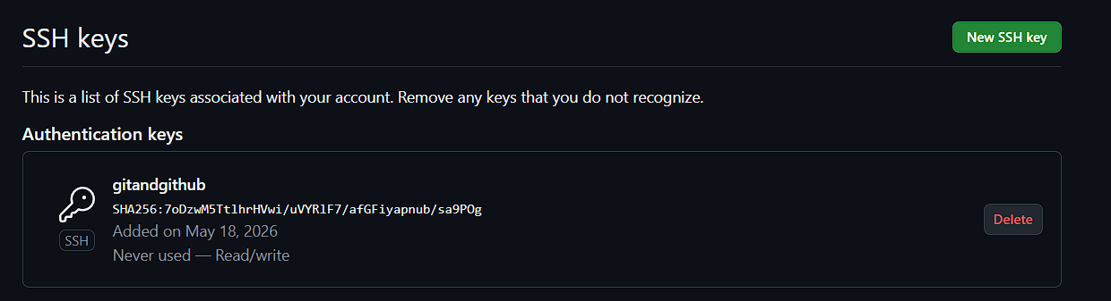

18. Configure webhooks to github.

19. Basic understanding of .git file.

- HEAD → Points to the current branch you’re working on.
- config → Repository-specific configuration (like remotes, user info).
- description → Used by GitWeb; usually not important for local repos.
- hooks/ → Scripts that run on certain Git actions (e.g., pre-commit, post-merge).
- info/ → Contains exclude file for ignored patterns (like .gitignore, but local only).
- objects/ → Stores all commits, trees, and blobs (your actual data).
- refs/ → Contains references to commits (branches, tags, remotes).
- logs/ → Keeps track of changes to refs (like branch movements).
- index → The staging area — snapshot of what will go into the next commit.

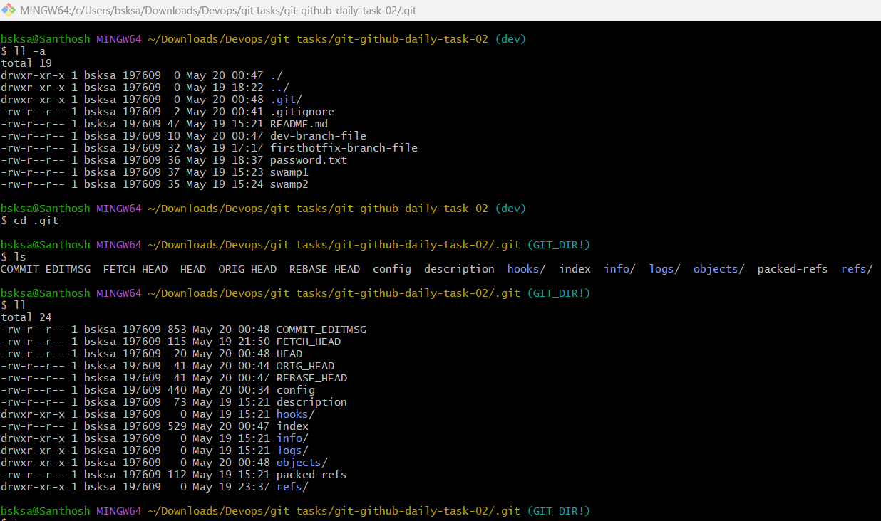

20. Check all the logs of git.

- To check all the logs of git git log
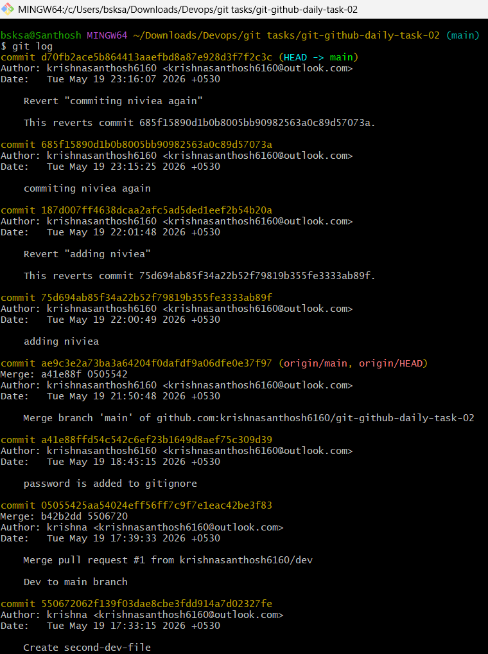

21. Rename the commit message.

- git commit --amend -m "New commit message"

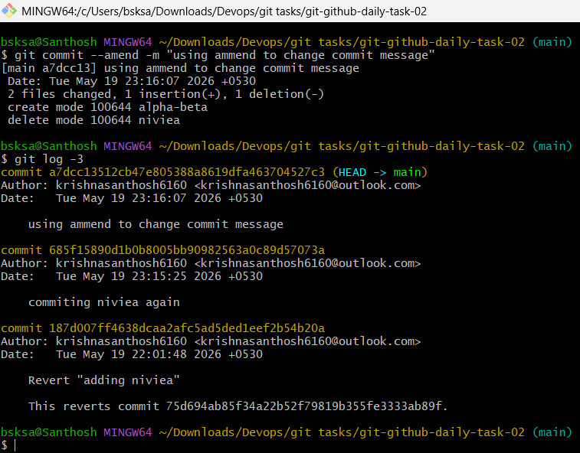

22. Merge multiple commits into single commit.

- git rebase -i head~n

